

Software requirements specification

Smart Safe Automation v1.0 (06/30/2017)

**Modification History**

|  |  |  |  |  |  |
| --- | --- | --- | --- | --- | --- |
| **Version**  **No.** | **Date**  **<mm/dd/yy>** | **Changes made** | **Author** | **Reviewers** | **Documents Affected** |
| 1.0 | 06/30/2017 | Creation | Carlos Valderrama |  | SRS |
|  |  |  |  |  |  |

Table of Contents

Introduction 3

Requirements 3

Current Solution 3

Proposed Solution 4

User Interfaces 5

Insert new Transfer 5

Appendix 6

A. Prosegur Voucher 6

B. Prosegur XML Web Service Request 7

C. Prosegur Service Specification 9

Software Requirements Specification

**Safe Vault Deposit Automation**

## Introduction

Each store saves money in safe vaults located in each store which are provided by two companies: Prosegur and Brinks. The cashiers deposit bills every day and get a voucher which data is uploaded into FxOnline Application. But there are issues because the information updated into the System is wrong and generates inconsistences in Accounting.

## Requirements

1. Validate information provided by each voucher generated in each Smart safe located in Ria Stores.
2. Update voucher information generated by smart safe into FxOnline.

## Current Solution



Currently, the cashier deposits money into Smart Safe in each store. The smart sage generates a voucher after the operation is completed. Finally, the cashier type all information in FxOnline as operation number, amount, denominations and quantity by each denomination. There is no information available to validate whether information is valid o there is inconsistent data typed by cashier. So, the information is uploaded to FxOnline and Accounting receive this information but it generated problems with conciliation between deposits and information provided by each cashier because errors in operation numbers, quantities and amounts. This produces waste of time trying to find out errors in data entry or errors in smart safe because of malfunction like stuck bills or electronic failures when deposits are being processed in smart safes.

## Proposed Solution



The solution consists of two phases. The first phase is to deposit money into Smart Safe and get a Deposit Voucher. This Deposit Voucher has information about amount, denomination, and quantity by each denomination. The information about deposit in each smart safe is sent on line to Prosegur Systems. The information is processed and sent again to RIA Systems through a SOAP Service published by RIA. The SOAP Service updates the FxOnline Database and it is available to be read by Core Api Service. This Core Api Service expose a method to be used by FxOnline.

The second phase is produced when the cashier types the operation number generated in the voucher. The screen in FxOnline populates all information contained in this voucher without any input from cashier, only the operation number generated by the Smart Safe. Thus, the information is completely validated and deposit is consistent with information located in Prosegur, Smart Safe and FxOnline. This avoids issues when Accounting tries to make conciliation in FxClient and Bank Deposits.

The appendix A shows a voucher generated by a device from Prosegur which has every denomination and quantity but it is impossible to know who is the cashier that makes the deposit because information printed is not relevant for this operation.

The appendix B shows the XML Example used by Prosegur Systems to invokes the SOAP Service in RIA. In this XML, Prosegur sends all details necessary to validate a voucher, and all this information must be inserted into the RIA Databases. The Web Service specification is attached in appendix C. Finally, this information will be retrieved by Core Api Service to populates the user interface in FxOnline.

## User Interfaces

### Insert new Transfer

The existing screen needs to get information from Core Api Service when cashier types “Numero de Referencia” and updates all information (amounts, denominations and quantities).



The screen must not allow to save information if the “Numero de Referencia” does not exist. This could be a configuration key in the System to allow or not allow insert not existing information into FxOnline.

## Appendix

### **Prosegur Voucher**

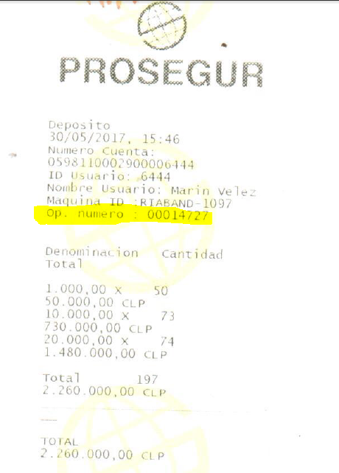

### **Prosegur XML Web Service Request**

<?xml version = "1.0" encoding = "UTF-8"?>

<ns0:CashTransactionRequest xmlns:ns0 = "<http://glo.prosegur.soa/CashTransaction/CashTransactionRequest>">

      <ns0:Device>

            <ns0:CountryId>CL</ns0:CountryId>

            <ns0:TimeZone>GMT-4:00</ns0:TimeZone>

            <ns0:Delegation>CL130</ns0:Delegation>

            <ns0:DeviceId>059811000290</ns0:DeviceId>

            <ns0:DeviceName>CIMA</ns0:DeviceName>

            <ns0:DeviceType>ACCEPTOR</ns0:DeviceType>

      </ns0:Device>

      <ns0:Client>

            <ns0:Customer>RIA BANDERA 1097</ns0:Customer>

            <ns0:Teller>0598110002900002535</ns0:Teller>

            <ns0:TellerName>Jhon Medina</ns0:TellerName>

      </ns0:Client>

      <ns0:Transaction>

            <ns0:TransType>CASHIN</ns0:TransType>

            <ns0:TransactionId>20170612153834_059811000290_CASHIN</ns0:TransactionId>

            <ns0:ReceiptNumber>15416</ns0:ReceiptNumber>

            <ns0:Date>12/06/2017</ns0:Date>

            <ns0:Time>15:38:34</ns0:Time>

            <ns0:Totals>

                  <ns0:Total Amount = "170000000" Currency = "CLP"/>

            </ns0:Totals>

            <ns0:TransUnits Boxname = "NOTEACCEPTOR">

                  <ns0:Mix BarCode = "" Currency = "CLP" Denomination = "2000000" NumItems = "49" Total = "98000000" Type = "NOTE"/>

                  <ns0:Mix BarCode = "" Currency = "CLP" Denomination = "1000000" NumItems = "72" Total = "72000000" Type = "NOTE"/>

            </ns0:TransUnits>

      </ns0:Transaction>

</ns0:CashTransactionRequest>

<?xml version = "1.0" encoding = "UTF-8"?>

<ns0:CashTransactionRequest xmlns:ns0 = "<http://glo.prosegur.soa/CashTransaction/CashTransactionRequest>">

      <ns0:Device>

            <ns0:CountryId>CL</ns0:CountryId>

            <ns0:TimeZone>GMT-4:00</ns0:TimeZone>

            <ns0:Delegation>CL130</ns0:Delegation>

            <ns0:DeviceId>059811000290</ns0:DeviceId>

            <ns0:DeviceName>CIMA</ns0:DeviceName>

            <ns0:DeviceType>ACCEPTOR</ns0:DeviceType>

      </ns0:Device>

      <ns0:Client>

            <ns0:Customer>RIA BANDERA 1097</ns0:Customer>

            <ns0:Teller/>

      </ns0:Client>

      <ns0:Transaction>

            <ns0:TransType>SHIPOUT</ns0:TransType>

            <ns0:TransactionId>20170612105252_059811000290_SHIPOUT</ns0:TransactionId>

            <ns0:ReceiptNumber>15395</ns0:ReceiptNumber>

            <ns0:Date>12/06/2017</ns0:Date>

            <ns0:Time>10:52:52</ns0:Time>

            <ns0:Totals>

                  <ns0:Total Amount = "8220500000" Currency = "CLP"/>

            </ns0:Totals>

            <ns0:TransUnits Boxname = "NOTEACCEPTOR">

                  <ns0:Mix BarCode = "" Currency = "CLP" Denomination = "200000" NumItems = "78" Total = "15600000" Type = "NOTE"/>

                  <ns0:Mix BarCode = "" Currency = "CLP" Denomination = "1000000" NumItems = "2670" Total = "2670000000" Type = "NOTE"/>

                  <ns0:Mix BarCode = "" Currency = "CLP" Denomination = "2000000" NumItems = "2580" Total = "5160000000" Type = "NOTE"/>

                  <ns0:Mix BarCode = "" Currency = "CLP" Denomination = "100000" NumItems = "1174" Total = "117400000" Type = "NOTE"/>

                  <ns0:Mix BarCode = "" Currency = "CLP" Denomination = "500000" NumItems = "515" Total = "257500000" Type = "NOTE"/>

            </ns0:TransUnits>

      </ns0:Transaction>

</ns0:CashTransactionRequest>

### **Prosegur Service Specification**

